DHANANI PRIVATE EQUITY GROUP
Salesforce CRM Implementation

FUNCTIONAL SPECIFICATION DOCUMENT
DISPOSITION MODULE
Sell Meter | BOV | 6-Week Rule | Closing | Investor Proceeds

Document Version | v1.0 — Disposition Module FSD
Date | June 2026
Prepared By | Aftab Ali — Lead Consultant, Avanza Solutions
Reviewed By | Akber Zaidi — Product Owner / Project Manager
Client | Dhanani Private Equity Group (DPEG)
Classification | CONFIDENTIAL — Client & Avanza Solutions Only
Status | Final — Pending Client Approval
Module | Disposition (Phase 1)

Prepared by Avanza Solutions | Confidential & Proprietary

Document Control & Revision History

Version | Date | Author | Change Summary
v0.1 | Apr 2026 | Aftab Ali | Initial Disposition module draft
v0.5 | May 2026 | Aftab Ali | Sell Meter, BOV workflow, 6-week rule added
v1.0 | Jun 2026 | Aftab Ali | Full FSD — all stages, field specs, UAT, integrations, visuals

Table of Contents

1. | Executive Summary
2. | Scope & Architecture Principles
2.1 | In-Scope
2.2 | Out of Scope
2.3 | Architecture Non-Negotiables
3. | Object Conversion Points
4. | Stage 0 — Sell Meter: Continuous Monitoring
4.1 | Sell Meter Formula
4.2 | Inputs & Data Sources
4.3 | Colour Thresholds & Trigger Actions
4.4 | CoStar & Argus Role in Sell Meter
5. | Stage 1 — Disposition Readiness
5.1 | Key Activities
5.2 | Disposition__c Fields at Creation
6. | Stage 2 — Broker Outreach & BOV
6.1 | Step-by-Step BOV Process
6.2 | BOV_Response__c Field Specification
6.3 | BOV Scoring Formula
7. | Stage 3 — Active Listing & Offers
7.1 | Broker_Listing__c Field Specification
7.2 | The 6-Week Broker Performance Rule
7.3 | Disposition_Offer__c Field Specification
7.4 | Automated Alerts Summary
8. | Stage 4 — Disposition Closing
9. | Wire Fraud Prevention Protocol
9.1 | The 6-Field Protocol
9.2 | Validation Rule
9.3 | Approval Process Flow
10. | Conversion 6 — Exit Distribution
11. | Complete Object Model
12. | Integration Architecture
13. | Disposition Dashboards
14. | UAT Test Scenarios
15. | End-to-End Flow Diagram
16. | Appendix — Object Relationship Summary

1. Executive Summary

The Disposition module manages the complete lifecycle of selling an owned real estate asset — from identifying the optimal sell window via automated financial signals, through broker management, offer tracking, closing, and final investor proceeds distribution.
Salesforce is a read-only display and workflow layer. It does not write back to Yardi, QuickBooks, or any source system. All financial data flows one direction: source systems feed Salesforce via the Avanza Service Bus (ASB) on AWS Lambda.
KEY OUTCOME: Junior replaces manual Excel disposition trackers with a colour-coded Sell Meter dashboard, automated BOV matrix, and system-enforced 6-week broker performance rule.

Capability | Current State | Target State (Salesforce)
Sell Timing | Manual NOI review, gut feel | Automated Sell Meter (GREEN/YELLOW/RED) — CoStar + Yardi/Argus
Broker Management | Excel tracker, email follow-ups | Broker_Listing__c with 6-week clock, alerts, backup list
BOV Comparison | Manual spreadsheet | Auto-generated matrix when 3+ responses received
Offer Tracking | Emails and notes | Disposition_Offer__c per buyer — full status lifecycle
Wire Fraud | Manual checklist (reminder) | System-enforced 6-field validation — hard gate, not reminder
Investor Proceeds | Manual IR notification | Automated Plaid ACH exit distribution at Conversion 6

2. Scope & Architecture Principles

2.1 In-Scope
- Sell Meter logic — continuous formula-driven monitoring on all Property_Asset__c
- Conversion 5: Property_Asset__c to Disposition__c (sell decision)
- Conversion 6: Disposition__c (Closed) to Property_Asset__c deactivated
- BOV outreach workflow — up to 6 brokers, auto-comparison matrix
- 6-Week broker performance rule with automated alerts
- Disposition offer tracking — Disposition_Offer__c per buyer offer
- PSA-triggered stage advancement to Closing
- Wire fraud prevention — 6-field system-enforced gate
- Nikil approval process for closing wire
- IR exit distribution notification via Plaid ACH
- Disposition dashboards for Junior and Ali (CFO)
- CoStar integration for Market_Cap_Rate__c via ASB weekly pull
- Yardi/Argus data feed for NOI__c
2.2 Out of Scope
- Write-back to Yardi, QuickBooks, or any source system (Salesforce is READ-ONLY)
- MuleSoft, Informatica, enterprise middleware — replaced by ASB on AWS Lambda
- Custom Broker__c object — standard Account and Contact objects used
- Placer.ai — Acquisitions-only; not used in Disposition
- Phase 2: Property Management, Leasing, Maintenance
2.3 Architecture Non-Negotiables
These rules were established during discovery and are locked. They cannot be revisited or alternatives suggested during implementation.

Rule | Detail
Read-Only Salesforce | Display layer only. Zero write-back to Yardi, QuickBooks, or any source system.
No Enterprise Middleware | ASB (Node.js on AWS Lambda) replaces MuleSoft/Informatica — excluded on cost grounds.
Standard Objects for Brokers | Account (Broker Firm) + Contact (Broker Rep). No custom Broker__c object.
Wire Fraud System-Enforced | All 6 wire validation fields are mandatory system gates — not reminders.
Only LOI Requires Nick Approval | Nick approves LOI only. Closing wire is approved by Nikil.

3. Object Conversion Points

The property remains an active Property_Asset__c throughout the entire sale process. It is deactivated ONLY at Conversion 6 when proceeds are confirmed.

Conversion | Trigger | From | To / Action
Conversion 5 | Sell_Meter__c = GREEN or Principal override | Property_Asset__c (Active) | Disposition__c created. Asset stays in AUM.
Conversion 6 | Closing wire confirmed + Nikil approval | Disposition__c (Stage = Closed) | Property_Asset__c.Status = Disposed. IR notified.

CONV  5 | Property_Asset__c to Disposition__c Created  Sell_Meter__c flips GREEN (or principal override) > Disposition__c record created. Asset stays in AUM. Property_Asset__c deactivated ONLY at Conversion 6.

CONV  6 | Disposition__c to Property_Asset__c Deactivated  Closing confirmed + Nikil approval > Stage = Closed, Property_Asset__c.Status = Disposed. Faiz (IR) immediately notified with net proceeds > Exit Distribution triggered.

4. Stage 0 — Sell Meter: Continuous Monitoring

Always-on automated indicator on every Property_Asset__c. Recalculates when CoStar pushes a new cap rate (weekly) or Yardi updates NOI (nightly).

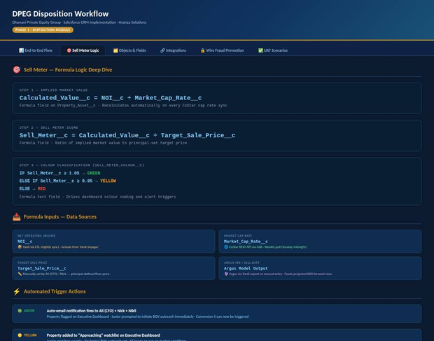
Figure 1: Sell Meter — Formula Inputs, Colour Thresholds & Trigger Actions
4.1 Sell Meter Formula
Step | Field API Name | Formula | Type
1 | Calculated_Value__c | NOI__c divided by Market_Cap_Rate__c | Formula — Currency
2 | Sell_Meter__c | Calculated_Value__c divided by Target_Sale_Price__c | Formula — Number (ratio)
3 | Sell_Meter_Colour__c | IF >= 1.05 GREEN / IF >= 0.95 YELLOW / ELSE RED | Formula — Text

4.2 Inputs & Data Sources
Input | API Name | Source | Cadence
Net Operating Income | NOI__c | Yardi via ETL — actuals | Nightly
Projected NOI / IRR | NOI__c (projected) | Argus via Yardi export or manual | On valuation update
Market Cap Rate | Market_Cap_Rate__c | CoStar REST API via ASB | Weekly — Sunday midnight
Target Sale Price | Target_Sale_Price__c | Manually set by Ali / Nick | On demand
Implied Market Value | Calculated_Value__c | Formula: NOI divided by Cap Rate | Auto-recalculates
Sell Meter Score | Sell_Meter__c | Formula: Implied divided by Target | Auto-recalculates
Sell Meter Colour | Sell_Meter_Colour__c | Formula: threshold logic | Auto-recalculates

4.3 Colour Thresholds & Trigger Actions
Colour | Condition | Automated Action
GREEN — Sell Now | Calculated_Value__c >= Target x 1.05 | Auto-email Ali + Nick + Nikil. Executive Dashboard flagged. Junior prompted for BOV outreach.
YELLOW — Approaching | Calculated_Value__c >= Target x 0.95 | Added to Approaching watchlist on dashboard. Weekly monitoring. No BOV yet.
RED — Hold | Calculated_Value__c < Target x 0.95 | No automated action. Asset remains under management.

4.4 CoStar & Argus Role in Sell Meter
System | Role | Stages Used
CoStar | Supplies Market_Cap_Rate__c — denominator in Sell Meter. Cap rate compression can flip multiple properties GREEN simultaneously. Weekly ASB pull. | Stage 0 (always on) + Stage 1
Argus | IRR projections and optimal sell timing via Yardi export. Forward-looking projected NOI dimension. Dashboard: Sell Now / In N months / Hold. | Stage 0 (projected NOI) + Stage 1
Placer.ai | NOT USED in Disposition. Acquisitions-only (foot traffic, tenant rankings). | N/A — Acquisitions only

NOTE: When CoStar pushes a new cap rate Sunday midnight, Sell_Meter_Colour__c recalculates for every Property_Asset__c simultaneously. A cap rate compression event can flip multiple properties GREEN at once.

5. Stage 1 — Disposition Readiness

STAGE  1 | Disposition Readiness | DECISION POINT

Item | Detail
Entry Criteria | Sell_Meter_Colour__c = GREEN OR Principal manual override
Stage Value | Disposition__c.Stage__c = 'Disposition Readiness'
Objects Active | Property_Asset__c, Market_Data__c, Disposition__c (Conversion 5)
Owner | Ali (CFO) reviews; Nick / Ali / Nikil confirm
Exit Criteria | Disposition__c created; advances to BOV Outreach

5.1 Key Activities
- Ali reviews dashboard: Sell Meter scores, Argus IRR projections, CoStar comps
- Principals (Nick, Ali, Nikil) confirm decision to sell
- Decision type recorded: 'System Triggered' or 'Principal Override'
- Conversion 5 fires: Disposition__c created from Property_Asset__c
- Financial data snapshotted: NOI__c, Market_Cap_Rate__c, Target_Sale_Price__c, Sell_Meter_Colour__c
5.2 Disposition__c Fields at Creation
Field Label | API Name | Type | Value at Creation
Stage | Stage__c | Picklist | Disposition Readiness
Linked Asset | Property_Asset__c | Lookup | Source property asset record
Target Sale Price | Target_Sale_Price__c | Currency | Carried from Property_Asset__c
NOI at Decision | NOI__c | Currency | Current Yardi actuals at creation
Market Cap Rate | Market_Cap_Rate__c | Percent | Current CoStar value at creation
Implied Value | Calculated_Value__c | Formula | NOI__c / Market_Cap_Rate__c
Sell Meter Score | Sell_Meter__c | Formula | Calculated_Value__c / Target_Sale_Price__c
Sell Meter Colour | Sell_Meter_Colour__c | Formula Text | GREEN / YELLOW / RED
Decision Type | Decision_Type__c | Picklist | System Triggered or Principal Override

6. Stage 2 — Broker Outreach & BOV

STAGE  2 | Broker Outreach & BOV (Broker Opinion of Value) | 5-6 BROKERS

Item | Detail
Entry Criteria | Disposition__c.Stage__c = 'BOV Outreach'
Objects Active | Disposition__c, BOV_Response__c, Account, Contact, ContentDocument
Auto-Trigger | When 3+ BOV_Response__c exist: BOV Comparison Matrix auto-generated
Exit Criteria | Winner selected; Broker_Listing__c created; Stage = 'Active Listing'

6.1 Step-by-Step BOV Process
Step | Action | Owner
6.1 | Junior assembles package: rent roll, NOI, photos, Argus output. Stored as ContentDocument on Disposition__c. | Junior
6.2 | Package sent to 5-6 firms via Marketing Cloud RFP email with submission deadline. | Junior / Mktg Cloud
6.3 | Each response creates a BOV_Response__c record in Salesforce. | Junior
6.4 | When 3+ received: BOV Comparison Matrix auto-generated. Junior notified. | Automated Flow
6.5 | Junior reviews matrix, selects winner (Status = 'Selected'). Others kept as backup list. | Junior
6.6 | Broker_Listing__c created. Stage advances to 'Active Listing'. | Junior / Flow

6.2 BOV_Response__c Field Specification
Field Label | API Name | Type | Detail
Linked Disposition | Disposition__c | Lookup | Parent disposition record
Broker Account | Account__c | Lookup to Account | Standard Account — Record Type: Broker Firm
Broker Contact | Contact__c | Lookup to Contact | Individual broker rep
BOV Amount | BOV_Amount__c | Currency | Broker's stated property value
Commission Rate | Commission_Rate__c | Percent | Broker's proposed commission %
Time to Market | Time_To_Market_Days__c | Number | Broker's estimated days to offer
Historical Success Rate | Historical_Success_Rate__c | Percent | Track record — manual or calculated
BOV Score | BOV_Score__c | Formula | 40% BOV/target + 25% commission(inv) + 20% TTM(inv) + 15% history
Status | Status__c | Picklist | Received / Under Review / Selected / Rejected

6.3 BOV Scoring Formula
Component | Weight | Direction
BOV Amount vs Target Price | 40% | Higher is better
Commission Rate | 25% | Lower is better (inverse)
Time to Market (days) | 20% | Faster is better (inverse)
Historical Success Rate | 15% | Higher is better

7. Stage 3 — Active Listing & Offers

STAGE  3 | Active Listing & Offers | 6-WEEK CLOCK

Item | Detail
Entry Criteria | Broker_Listing__c.Status__c = 'Active'
Clock Start | List_Date__c starts the 6-week performance clock
21-Day Alert | No Disposition_Offer__c after 21 days — alert fires to Junior
Exit Criteria | PSA_Executed__c = TRUE on accepted offer — Stage = 'Closing'

7.1 Broker_Listing__c Field Specification
Field Label | API Name | Type | Detail
Linked Disposition | Disposition__c | Lookup | Parent disposition record
Listing Broker | Contact__c | Lookup to Contact | Selected broker rep
Broker Firm | Account__c | Lookup to Account | Standard Account — no custom Broker__c
List Date | List_Date__c | Date | Starts the 6-week clock
Days On Market | Days_On_Market__c | Formula | TODAY() minus List_Date__c
Commission | Commission__c | Currency | Agreed commission amount or %
Call for Offers Date | Call_For_Offers_Date__c | Date | Broker-announced offer deadline
Status | Status__c | Picklist | Active / Paused / Expired / Replaced

7.2 The 6-Week Broker Performance Rule
HARD CUTOFF: System enforces it automatically. Prompts Junior — does NOT auto-reassign without action.

Week | Alert | Action Required
+2 weeks | Auto-email to broker + Ali | Broker provides pipeline update (tours, enquiries, feedback)
+4 weeks | Property flagged on Junior dashboard | Junior: continue or prepare transition to backup broker
+6 weeks | HARD DECISION PROMPT + alert email | Junior must act: extend OR replace broker from BOV backup list
Any week (offer received) | Disposition_Offer__c created | 6-week clock PAUSES while offer is active

7.3 Disposition_Offer__c Field Specification
Field Label | API Name | Type | Detail
Linked Disposition | Disposition__c | Lookup | Parent disposition record
Linked Listing | Broker_Listing__c | Lookup | Which listing generated this offer
Offer Amount | Offer_Amount__c | Currency | Buyer's offered purchase price
Buyer Type | Buyer_Type__c | Picklist | 1031 Exchange / Institutional / Private
Offer Date | Offer_Date__c | Date | Date received — pauses 6-week clock
Status | Status__c | Picklist | Received / Under Review / Accepted / Rejected / Countered
PSA Executed | PSA_Executed__c | Checkbox | TRUE auto-advances stage to 'Closing'
PSA Date | PSA_Date__c | Date | Date PSA was executed

7.4 Automated Alerts Summary
Trigger | Automation | Recipients
Day 21 — No Disposition_Offer__c | Alert email fires to Junior | Junior
Week 4 — No offers | YELLOW flag on Junior dashboard | Junior (dashboard)
Week 6 — No offers | Hard decision prompt + alert email | Junior + Ali (CFO)
PSA_Executed__c = TRUE | Stage advances to 'Closing'. Closing tasks spawned. | Danish (tasks)

8. Stage 4 — Disposition Closing

STAGE  4 | Disposition Closing | PSA EXECUTED

Item | Detail
Entry Criteria | PSA_Executed__c = TRUE on accepted Disposition_Offer__c
Objects Active | Disposition__c, Transaction__c, Title_Company__c, Wire__c, Property_Asset__c, ContentDocument
Owner | Danish (Transaction Lead) — Nikil (Final wire approval)
Exit Criteria | Wire confirmed + Nikil approval — Conversion 6 fires

Step | Action | Object | Owner
8.1 | PSA executed. Stage = 'Closing'. Closing tasks spawned from 75-task Transaction model. | Transaction__c (new) | Automated Flow
8.2 | Title_Company__c assigned. Title coordination tasks created. | Title_Company__c | Danish
8.3 | Closing statement reviewed and uploaded as ContentDocument. | ContentDocument | Danish
8.4 | Wire__c created. ALL 6 fraud-prevention fields required before save. | Wire__c | Danish
8.5 | Validation Rule: record cannot save if any field is missing. | Wire__c | System-enforced
8.6 | Nikil signs off on closing wire via Approval Process. | Approval Process | Nikil
8.7 | CONVERSION 6: Stage = Closed, Property_Asset__c.Status = Disposed. | Disposition__c + Asset | Automated Flow
8.8 | Faiz (IR) notified with net proceeds. Exit Distribution triggered. | Distribution_Batch__c | Flow to IR

9. Wire Fraud Prevention Protocol

Wire fraud in real estate exceeded $400M in 2023 (FBI). DPEG has had near-miss incidents. The 6-field Validation Rule makes it technically impossible to save a Wire__c record without completing the full verbal verification protocol.
CRITICAL — SYSTEM ENFORCED: ALL 6 fields mandatory. Validation Rule fires on Save. Record cannot save in any partial state. Not a reminder — a hard gate.

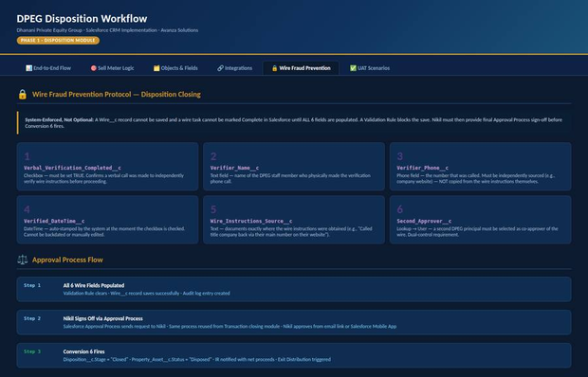
Figure 2: Wire__c — 6 Mandatory Fields & Approval Process
9.1 The 6-Field Protocol
# | Field (API Name) | Requirement
1 | Verbal_Verification_Completed__c (Checkbox) | Must be TRUE. Confirms verbal call made to independently verify wire instructions.
2 | Verifier_Name__c (Text) | Name of DPEG staff member who made the verification call.
3 | Verifier_Phone__c (Phone) | Number called. Must be independently sourced — NOT from the wire instructions.
4 | Verified_DateTime__c (DateTime) | Auto-stamped by system. Cannot be backdated.
5 | Wire_Instructions_Source__c (Text) | Where instructions were obtained (e.g. 'Called title company via main line').
6 | Second_Approver__c (Lookup to User) | Second DPEG principal co-approver. Dual-control requirement.

9.2 Validation Rule
API Name: Wire_Fraud_Prevention
OR( ISBLANK(Verbal_Verification_Completed__c), ISBLANK(Verifier_Name__c), ISBLANK(Verifier_Phone__c), ISBLANK(Verified_DateTime__c), ISBLANK(Wire_Instructions_Source__c), ISBLANK(Second_Approver__c) )
Error Message: 'Wire record cannot be saved. All 6 fraud-prevention fields are mandatory.'
9.3 Approval Process Flow
Step | Action | Owner | Outcome
1 | All 6 fields populated. Validation clears. Record saves. Audit log created. | Danish | Wire__c saved + audit trail
2 | Approval request sent to Nikil with wire summary. | Automated | Nikil receives email + mobile notification
3 | Nikil approves or rejects. | Nikil | Approval: Conversion 6. Rejection: back to Danish.
4 | Conversion 6 fires on approval. | Automated Flow | Stage = Closed; Property = Disposed; IR notified

10. Conversion 6 — Exit Distribution

CONV  6 | Disposition__c to Property_Asset__c Deactivated  Stage = 'Closed'. Property_Asset__c.Status = 'Disposed'. AUM updated. Faiz (IR) notified immediately with net proceeds. Exit Distribution triggered.

10.1 Conversion 6 Trigger Actions
Action | Object | Field / Value
Stage set to Closed | Disposition__c | Stage__c = 'Closed'
Property marked Disposed | Property_Asset__c | Status__c = 'Disposed'
Removed from AUM Dashboard | Property_Asset__c | Active AUM filter excludes Disposed
IR Notification | Flow notification to Faiz | Net proceeds amount sent immediately
Exit Distribution created | Distribution_Batch__c | Type__c = 'Exit'

10.2 Exit Distribution — IR Module
Step | Action | Detail
1 | Flow notifies Faiz (IR) with net proceeds immediately. | Same moment as Conversion 6
2 | Faiz creates Distribution_Batch__c (Type = 'Exit'). | Type__c = Exit
3 | System calculates each investor's share. | Equity_Pct__c x net proceeds
4 | Plaid ACH batch executes payments to all investors. | Real-time ACH batch
5 | Investors notified via Experience Cloud + Marketing Cloud. | Portal notification + email

11. Complete Object Model — Disposition

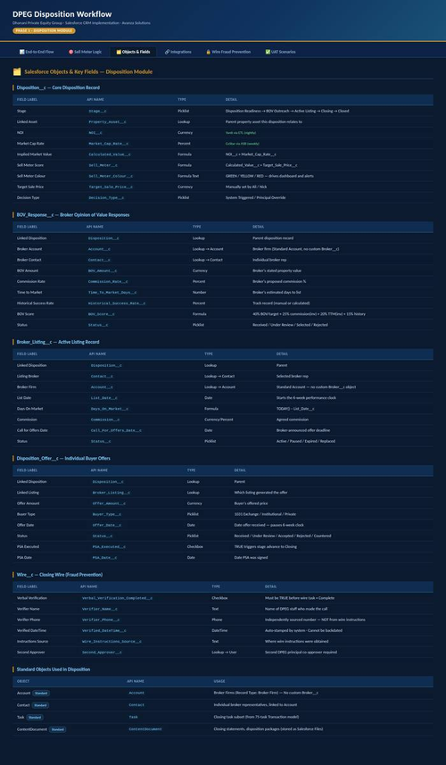
Figure 3: All Salesforce Objects & Key Fields — Disposition Module
11.1 Custom Objects Summary
Object | API Name | Purpose
Disposition | Disposition__c | Core record — sell meter, stage, offers, proceeds
BOV Response | BOV_Response__c | One per broker response; score, amount, commission
Broker Listing | Broker_Listing__c | Active listing; days on market, 6-week clock
Disposition Offer | Disposition_Offer__c | Individual buyer offers; PSA tracking
Wire | Wire__c | Closing wire — 6 mandatory fraud-prevention fields
Title Company | Title_Company__c | Title assignment per closing
Property Asset | Property_Asset__c | Portfolio AUM record spanning PM, Disposition, IR
Distribution Batch | Distribution_Batch__c | Exit distribution batch; Type = 'Exit'

11.2 Standard Objects Used
Object | API Name | Usage
Account | Account | Broker Firms (Record Type: Broker Firm). Standard — no Broker__c.
Contact | Contact | Individual broker reps linked to Account.
Task | Task | Closing task subset from 75-task Transaction model. Assigned to Danish.
ContentDocument | ContentDocument | Closing statements, disposition packages (Salesforce Files).
Transaction | Transaction__c | New Transaction record at Closing stage with closing tasks.

12. Integration Architecture — Disposition

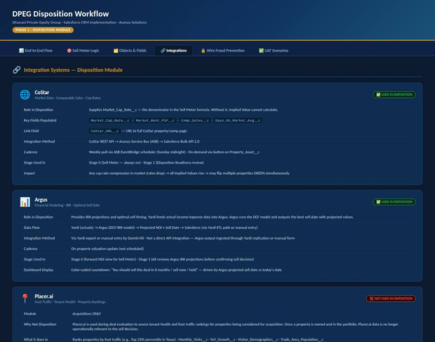
Figure 4: External Integration Systems — Disposition Usage
12.1 Integration Overview
System | Used? | Method | Cadence
CoStar | YES — Critical | CoStar REST API via ASB to SF Bulk API 2.0 | Weekly — Sunday midnight
Argus | YES — Data Input | Yardi export or manual entry | On valuation update
Yardi | YES — NOI Source | DB Replication + Lambda ETL | Nightly
Plaid | YES — Post-Close | ASB REST + Plaid ACH API | On-demand post-close
Placer.ai | NO — Acquisitions only | N/A | N/A

12.2 CoStar Integration Detail
Item | Detail
API | CoStar REST API (DPEG subscription required)
Auth | API key in ASB Secrets Vault — never stored in Salesforce
Fields Populated | Market_Cap_Rate__c, Market_Rent_PSF__c, Comp_Sales__c, CoStar_URL__c
Cadence | Weekly EventBridge scheduler; on-demand button on Property_Asset__c
Disposition Use | Stage 0 (Sell Meter denominator) + Stage 1 (Ali reviews comps)

12.3 Argus Integration Detail
Item | Detail
Role | IRR projections and optimal sell timing via Yardi export. DCF model: best sell date + projected NOI.
Data Flow | Yardi (actuals) to Argus (DCF/IRR) to Projected NOI + Sell Date to Salesforce (Yardi ETL or manual)
Dashboard | Colour-coded countdown: Sell Now / In N months / Hold — Argus projected date vs today
Disposition Use | Stage 0 (projected NOI) + Stage 1 (Ali reviews IRR before sell decision)

13. Disposition Dashboards

13.1 Disposition Dashboard — Junior & Ali (CFO)
Widget | Type | Purpose
Sell Meter Gauge — All Properties | Table / Card | Every asset sell readiness — GREEN/YELLOW/RED
Properties GREEN — Ready to Sell | Filtered List | Actionable list ready for BOV outreach now
Active Dispositions by Stage | Pipeline View | Full disposition pipeline stage by stage
BOV Comparison Pending | List | Chase remaining BOV responses (1-2 received)
6-Week Clock — At Risk | List | Early warning before 6-week cutoff
Proceeds Distributed (YTD) | KPI Card | Total investor exit proceeds year-to-date

14. UAT Test Scenarios

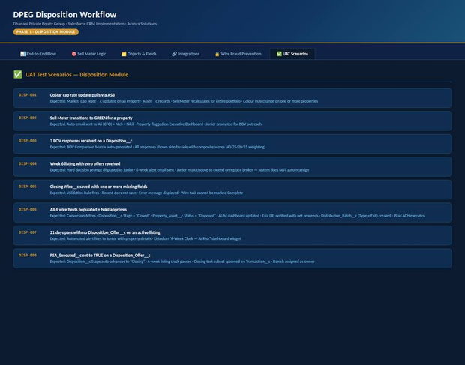
Figure 5: UAT Test Scenarios — Disposition Module
Test ID | Scenario | Expected Result
DISP-001 | CoStar cap rate update via ASB | Market_Cap_Rate__c updated; Sell Meter recalculates portfolio-wide; colour may change
DISP-002 | Sell Meter turns GREEN | Auto-email to Ali + Nick + Nikil; Dashboard flagged; Junior prompted for BOV
DISP-003 | 3 BOV_Response__c received | BOV Comparison Matrix auto-generated with composite scores (40/25/20/15)
DISP-004 | Week 6 listing — no offers | Hard decision prompt to Junior; alert email sent; no auto-reassignment
DISP-005 | Wire__c saved with missing fields | Validation Rule fires; record blocked; error message shown
DISP-006 | All 6 wire fields + Nikil approval | Conversion 6 fires; Stage = Closed; Property = Disposed; IR notified
DISP-007 | 21 days — no offers on listing | Alert email to Junior; property on 6-Week At Risk widget
DISP-008 | PSA_Executed__c = TRUE | Stage advances to 'Closing'; clock pauses; closing tasks spawned; Danish assigned

15. End-to-End Flow Diagram

Complete disposition lifecycle — always-on Sell Meter through both conversion points, all four stages, and final exit distribution to investors.

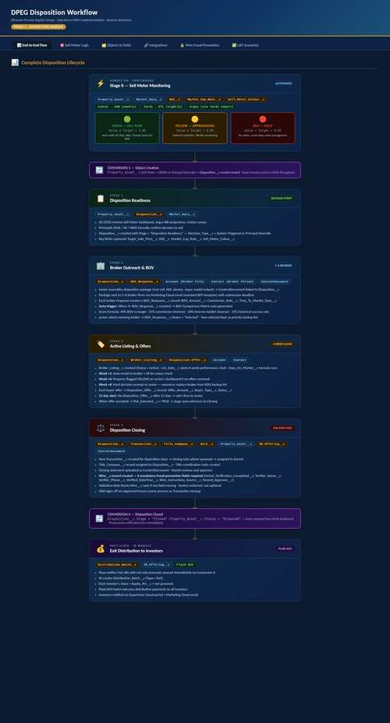
Figure 6: Complete Disposition Lifecycle — Stages, Objects, Conversions & Integrations

16. Appendix — Object Relationship Summary

Parent Object | Child / Related | Relationship | Notes
Property_Asset__c | Disposition__c | Lookup | One active Disposition__c per asset
Disposition__c | BOV_Response__c | Child | 5-6 BOV responses per disposition
Disposition__c | Broker_Listing__c | Child | Active + history of expired/replaced
Disposition__c | Disposition_Offer__c | Child | Multiple offers per disposition
Disposition__c | Transaction__c | Lookup | New Transaction at Closing stage
Disposition__c | Title_Company__c | Lookup | One title company per closing
Disposition__c | Wire__c | Child | Closing wire — 6 fraud-prevention fields
Broker_Listing__c | Disposition_Offer__c | Lookup | Offers linked to generating listing
Account | Contact | Standard | Broker Firm to Broker Representative
Account | BOV_Response__c | Lookup | Broker Firm on each BOV response
Contact | BOV_Response__c | Lookup | Broker Rep on each BOV response
Contact | Broker_Listing__c | Lookup | Selected listing broker rep
Distribution_Batch__c | IR_Offering__c | Lookup | Exit distribution to IR offering

